MATERIAL SAFETY DATA SHEET
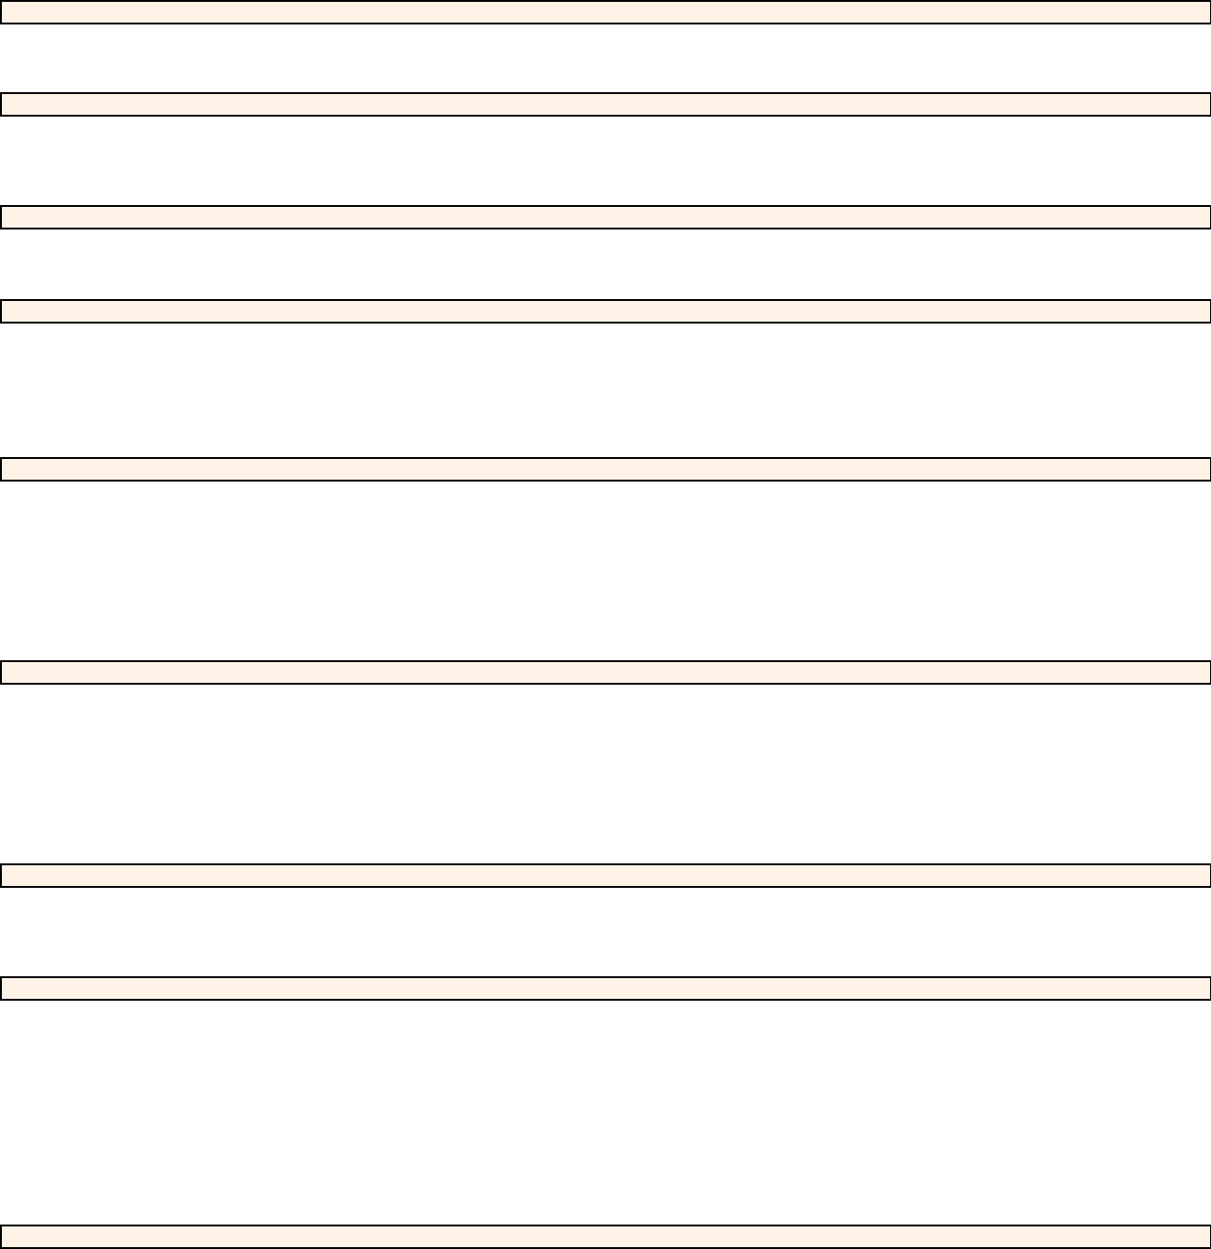

SECTION: 1.1 PRODUCT IDENTIFICATION

Product Name:

Country of Origin:

Atlas Cedar Oil

India

Company:

Address:

SECTION: 1.2 COMPANY IDENTIFICATION

Phytos Natur CZ s.r.o.

Okrouhelská 258, 252 45 Březová-Oleško

Major Constituents:

SECTION: 2. COMPOSITION / INFORMATION INGREDIENTS b-himalachene, a-himachalene, γ-himachalene

Hazardous Ingredients :

None

SECTION: 3. HAZARDS IDENTIFICATION

Routes of Entry, Eyes, Skin, Inhalation, Ingestion:

In case of skin contact (irritant), of eye contact (irritant), of ingestion, of inhalation.

- Inflammation of the eye is characterized by redness, watering, and itching.

- Skin inflammation is characterized by itching, scaling, reddening, or, occasionally, blistering.

This liquid should not be used as a fragrance ingredient at a level over 1% in a compound when skin contact is possible.

Eye Contact:

Inhalation:

Ingestion:

Skin Contact:

SECTION: 4. FIRST AID MEASURES

Remove contact lenses if applicable. Flush with plenty of water or eye wash solution for 15 minutes.

Seek medical attention if irritation persists.

Avoid gross inhalation of fumes. Remove to fresh air

Drink water or milk to dilute and contact poison control center or

seek medical attention immediately.

Remove contaminated clothing wash with soap and plenty of water. See medical attention if irritation

Persists.

SECTION: 5. FIRE FIGHTING MEASURES

Flammability:

Extinguishing media:

Note:

Special Firefighting Procedures:

Unusual Fire & Explosion Hazards:

Combustion Product:

Non Flammable

Dry Chemical, Carbon Dioxide, Foam

Do not use water jet.

Fire fighters should wear positive pressure self-contained breathing apparatus. Cool containers exposed

to flame with water spray. Spray extinguishing media directly into base of fire

None

Carbon Monoxide, Carbon Dioxide.

Personal Precautions:

Environmental Precautions:

Methods For Cleaning Up:

SECTION: 6. ACCIDENTAL RELEASE MEASURES

Remove all source of ignition

Prevent entry to sewers

Use soap and water

Handling:

Storage:

SECTION: 7. HANDLING AND STORAGE

Avoide inhalation and contact with skin and eyes. Good personal hygiene practices should be used.

Wash after any cantact, before breaks and meals, and at the end of the work period. Contaminated

clothing and shoes should be cleaned before re-use.

Wear eye protection, gloves and aprons. Ventilate area well.

Requirements for Storage Areas

and Containers:

Flammable materials should be stored in a separate safety storage cabinet or room. Keep away from heat. Keep away from sources of ignition.Keep container tightly closed. Keep in a cool,well-ventilated place. Ground all equipment containing material. Keep container dry. Keep in a cool place

Eyes Protection:

Respiratory Protection:

Protective Clothing:

SECTION: 8. EXPOSURE CONTROLS AND PERSONAL PROTECTION

The use of safety glasses is recommended. If a material is to be handled in a manner where splashing

may occur, goggles are recommended.

In well- ventilated areas, respiratory protection is not normally required. In confined, poorly ventilated

areas approved respiratory protection is normally required.

Using chemical resistant clothing is recommended.

Page 1 of 2

Page 2 of 2

Work Practice Controls:

Personal hygiene is an important work practice exposure control measure and the following general

measures should be takenwhen working with or handling this material:

(1) Do not store, use, and/or consume foods, beverages, tobacco products, or cosmetics in areas

where this material is stored. (2) Wash hands and face carefully before eating, drinking, using

tobacco, applying cosmetics, or using the toilet.

(3) Wash exposed skin promptly to remove accidental splashes or contact with this material.

No Hazards, Natural Products
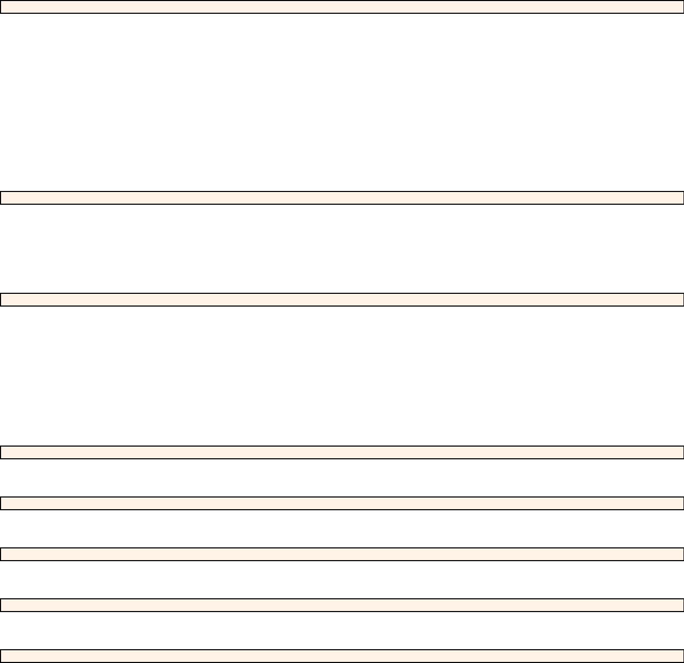

Color & Appearance:

Odor:

Physical State:

Boiling Point:

pH:

Melting Point:

Flash Point:

Solubility:

Specific Gravity:

Refractive Index:

Flammability:

Auto Flammability:

Explosive Properties:

SECTION: 9. PHYSICAL AND CHEMICAL PROPERTIES

Pale yellow to golden yellow liquid.

Sweet, warm, balsamic odor

Liquid

N.A.

N.A.

N.A.

>100°C

Soluble in 90% ethanol

0.9240 - 0.9450 @ 20°C

1.500 - 1.520 @ 20°C

No

No

No

Stability:

Conditions to Avoid:

Materials to Avoid:

Hazardous Polymerization:

Hazardous Combustion or

Decomposition products:

SECTION: 10. STABILITY AND REACTIVITY

This material is stable under normal conditions

Avoid contact with sparks, flame and heat.

Avoid contact with strong oxidizing agents and avoid hot work and sources of

Will not occur.

None known.

Acid fumes and carbon monoxide smoke.

ignition on or near empty containers.

Inhalation:

Skin Contact:

Eye Contact:

Ingestion:

Chronic Toxicity:

Carcinogenicity Data:

Reproductive Toxicity:

Acute Toxicity Values:

SECTION: 11. TOXICOLOGICAL INFORMATION

Inhalation of high concentrations of vapor may result in irritation of eyes, nose and throat, headache,

nausea, and dizzines.

Repeated or prolonged contact can cause redness, irritation and scaling of skin (Dermatitis) .

Adverse skin effects should be prevented by normal care and personal hygiene.

May irritate eyes.

Low order toxicity causing irritation of the stomach and intestines which results in nausea and vomiting.

May cause allergic reactions on skin.

None of the components of this material are listed as a carcinogen.

No adverse effects on reproduction are known.

No data is currently available.

SECTION: 12. ECOLOGICAL INFORMATION

Very toxic to aquatic organism may cause long-term adverse effects in the aquatic environment. Avoid

any pollution of ground, surface or underground water.

Waste Disposal Methods:

Precautions:

SECTION: 13. DISPOSAL CONSIDERATION

There should be no product residues.Dispose according to local, state and Federal regulations.

Prevent surface contamination of soil, ground and surface water.

SECTION: 14. TRANSPORT INFORMATION

DOT Hazard Classification: NA

As per ICAO and IATA regulation the products is not dangerous according to prevailing transport regulation.

SECTION: 15. REGULATORY INFORMATION

Regulatory :

FEMA no:

Not Regulated

NA

SECTION: 16. OTHER INFORMATION

This information is based on our present state of knowledge. It should not be therefore be construed as guaranteeing specific properties of the product described. It must be pointed that values for certain properties are known; to vary from source to source.It is the responsibility of the user to determine the best precautions for the safe handling and use of this product for your application. This safety sheet cannot cover all possible situations which the user may experience duringp rocessing. Each aspect of your operation should be examined to determine if, or where, additional precautions may be necessary.

