

**IFRA Conformity Certificate**

|  |  |  |  |
| --- | --- | --- | --- |
| Product Name | Sandalwood essential Oil | | |
| Botanical Name | SANTALUM ALBUM | | |
| Revision No | 1 | Date | June 2022 |

We certify that the above compound is in compliance with the Standards of the INTERNATIONAL FRAGRANCE ASSOCIATION (IFRA 50th Amendment / published June 2020), provided it is used in the following class(es)) at a maximum concentration level of:

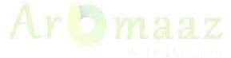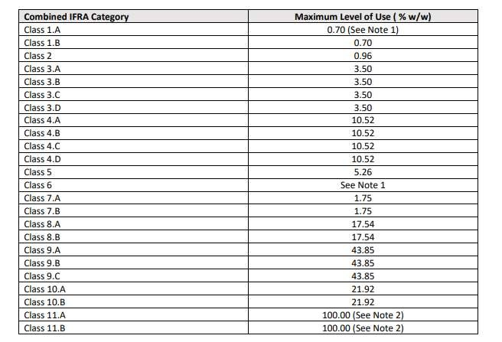

**IFRA Conformity Certificate**

The IFRA Standards regarding use restrictions are based on safety assessments by the Panel of Experts of the RESEARCH INSTITUTE FOR FRAGRANCE MATERIALS (RIFM) and are

enforced by the IFRA Scientific Committee.

Evaluation of individual Fragrance ingredients is made according to the safety standards contained in the relevant section of the IFRA Code of Practice.

This certificate serves only as a guide to the maximum level of use. It is the ultimate responsibility of the customer to ensure safe formulating principles are utilised and the safety of the final product (containing this fragrance), by further testing if need be.

Note 1: It is recommended that any material used to impart perfume or flavour in products intended for human ingestion should consist of ingredients that are in compliance with appropriate regulations for foods and food flavourings in the countries of planned distribution.

Note 2: Trials must be performed to satisfy suitability for specified application.

**DISCLAIMER: This information relates only to the specific material designated and may not be valid for such material used in combination with any other materials or in any process. Such information is, to the best of the company's knowledge and belief, accurate and reliable as of the date indicated. However, no warranty guarantee or representation is made to its accuracy, reliability or completeness. It is the user's responsibility to satisfy himself as to the suitability of such information for his own particular use.**

**ANNEX: Definition of IFRA Classes**

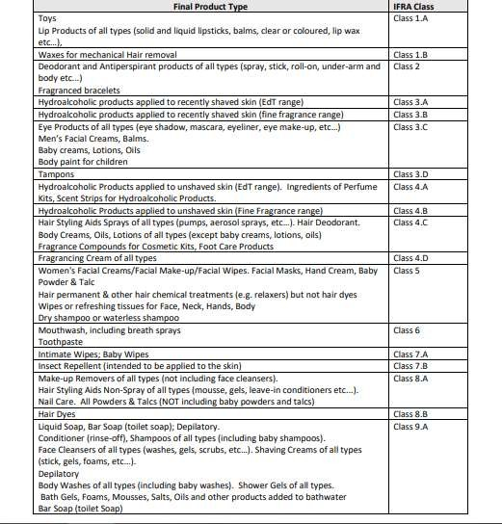

S

