IFRA CERTIFICATE OF CONFORMITY

Product Name: | JANTAR EO
Botanical Name: | Pinus succinefera
Release date: | 12.7.2024

We certify that the above product is in compliance with the Standards of the INTERNATIONAL FRAGRANCE ASSOCIATION (IFRA), up to and including the 51st Amendment to the IFRA Standards (published July, 2023), provided it is used in the following categories at a maximum concentration level of:

IFRA Categories [See Annex for details] | Maximum level of use (%)
Category 1 | Not Approved
Category 2 | 2.02
Category 3 | 0.69
Category 4 | 9.18
Category 5A | 7.23
Category 5B | 1.35
Category 5C | 3.39
Category 5D | 0.32
Category 6 | Not Approved
Category 7A | 1.69
Category 7B | 1.69
Category 8 | 0.56
Category 9 | 3.23
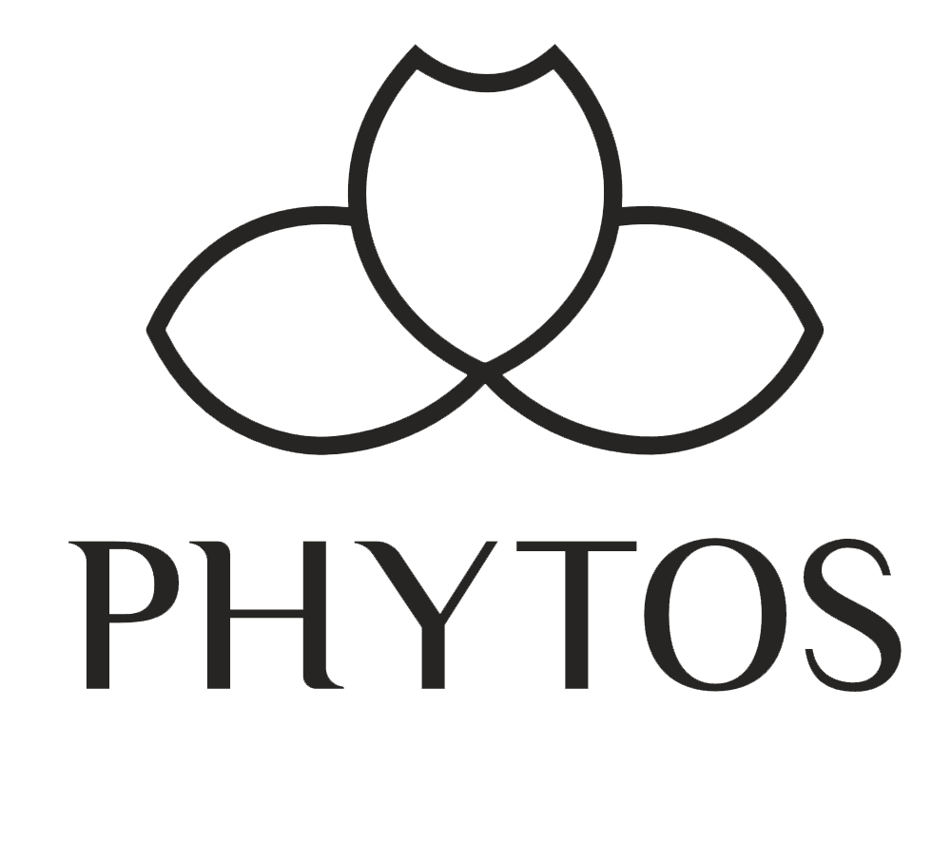  Category 10A | 3.23
Category 10B | 17.99
Category 11A | 0.67
Category 11B | 0.67
Category 12 | 100.0

The IFRA Standards regarding use restrictions are based on safety assessments by the Panel of Experts of the RESEARCH INSTITUTE FOR FRAGRANCE MATERIALS (RIFM) and are enforced by the IFRA Scientific Committee. It is the ultimate responsibility of our customer to ensure the safety of the final product by further testing if need be.

ANNEX I: Guidance for the use of IFRA Standards

Category | Product Type | Phototoxicity considerations
1 | Products applied to the lips | Applicable (leave-on)
2 | Products applied to the axillae | Applicable (leave-on)
3 | Products applied to the face/body using fingertips | Applicable (leave-on)
4 | Products related to fine fragrance | Applicable (leave-on)
5 | Products applied to the face and body using the hands (palms), primarily leave-on:
5A | Body lotion products applied to the body using the hands (palms), primarily leave-on | Applicable (leave-on)
5b | Face moisturizer products applied to the face using the hands (palms), primarily leave-on | Applicable (leave-on)
5C | Hand cream products applied to the hands using the hands (palms), primarily leave-on | Applicable (leave-on)
5D | Baby creams, baby Oils and baby talc | Applicable (leave-on)
6 | Products with oral and lip exposure | Applicable (rinse-off)
7 | Products applied to the hair with some hand contact:
7A | Rinse-off products applied to the hair with some hand contact | Applicable (rinse-off)
7B | Leave-on products applied to the hair with some hand contact | Applicable (leave-on)
8 | Products with significant anogenital exposure | Applicable (leave-on)
9 | Products with body and hand exposure, primarily rinse off | Applicable (rinse-off)
10 | Household care products with mostly hand contact:
10A | Household care excluding aerosol products (excluding aerosol/spray products) | Applicable (rinse-off)
10B | Household aerosol/spray products | Applicable (leave-on)
11 | Products with intended skin contact but minimal transfer of fragrance to skin from inert substrate:
11A | Products with intended skin contact but minimal transfer of fragrance  to skin from inert substrate without UV exposure | Not applicable (leaveon without UV exposure)
11B | Products with intended skin contact but minimal transfer of fragrance  to skin from inert substrate without UV exposure | Applicable (leave-on)
12 | Products not intended for direct skin contact, minimal or insignificant  transfer to skin | Not applicable (nonskin contact)

Annex II: List of IFRA categories and subcategories with corresponding product

Category | Product Type
1 | Lip Products of all types (solid and liquid lipsticks, balms, clear or colored, etc.) // Children's toys
2 | Deodorant and antiperspirant products of all types including any product with intended or reasonably foreseeable use on the axillae or labelled as such (spray, stick, roll-on, under-arm, deo- cologne, etc.) // Body sprays (including body mist)
3 | Eye products of all types (eye shadow, mascara, eyeliner, eye make-up, eye masks, eye pillows, etc.) including eye care and moisturizer // Facial make up and foundation // Make-up remover for face and eyes // Nose pore strips // Wipes or refreshing tissues for face, neck, hands, body // Body and face paint (for children and adults) // Facial masks for face and around the eyes
4 | Hydroalcoholic and non- hydroalcoholic fine fragrance of all types (Eau de Toilette, Parfum, Cologne, solid perfume, fragrancing cream, etc.), aftershaves of all types (except creams and balms) // Fragranced bracelets // Ingredients of perfume kits and fragrance mixtures for cosmetic kits // Scent pads, foil packs // Scent strips for hydroalcoholic products
5a | Body creams, oils, lotions of all types // Foot care products (creams and powders) // Insect repellent (intended to be applied to the skin) // All powders and talc (excluding baby powders and talc)
5b | Facial toner // Facial moisturizers and creams (including care products for beard and mustache)
5C | Hand cream // Nail care products including cuticle creams, nail lacquer remover, etc. // Hand sanitizers
5D | Baby cream/lotion, baby oil, baby powders and talc
6 | Toothpaste // Mouthwash, including breath sprays // Toothpowder, strips, mouthwash tablets
7A | Hair permanent or other hair chemical treatments (rinse-off) (e.g., relaxers), including rinse-off hair dyes
7B | Hair sprays of all types (pumps, aerosol sprays, etc.) // Hair styling aids non sprays (mousse, gels, leave-on conditioners) // Hair permanent or other hair chemical treatments (leave-on) (e.g., relaxers), including leave-on hair dyes // Shampoo - Dry (waterless shampoo) // Hair deodorizer, hair perfume
8 | Intimate wipes // Intimate deodorant spray // Tampons // Baby wipes // Toilet paper (wet)
9 | Bar soap // Shampoo of all types // Cleanser for face (rinse-off) // Conditioner (rinse-off) // Liquid soap // Body washes and shower gels of all types // Baby wash, bath, shampoo // Bath gels, foams, mousses, salts, oils and other products added to bathwater (such as bath bombs) // Footcare products (feet are placed in a bath for soaking) // Shaving creams of all types (stick, gels, foams, etc.) // All depilatories (including facial) and waxes for mechanical hair removal // Shampoos for pets
10A | Hand wash laundry detergent (including concentrates) // Laundry pre-treatment of all types (e.g. paste, sprays, sticks) // Hand dishwashing detergent (including concentrates) // Hard surface cleaners of all types (bathroom and kitchen cleansers, furniture polish, etc.) // Machine laundry detergents with skin contact (e.g., liquids, powders) including concentrates // Toilet seat wipes // Fabric softeners of all types excluding fabric softener sheets // Household cleaning products, other types including fabric cleaners, soft surface cleaners, carpet cleaners, furniture polishes sprays and wipes, leather cleaning wipes, stain removers, fabric enhancing sprays, treatment products for textiles (e.g., starch sprays, fabric treated with fragrances after wash, deodorizers for textiles or fabrics) // Floor wax // Fragranced oil for lamp ring, reed diffusers, pot-pourri, liquid refills for air fresheners (non-cartridge systems), etc. // Ironing water (Odorized distilled water) // Dry cleaning kits (involving manual application on the textile)
10B | Animal sprays – sprays applied to animals of all types // Air freshener sprays, manual, including aerosol and pump // Aerosol/spray insecticides
11A | Feminine hygiene conventional pads, interlabial pads // Baby diapers // Incontinence pant, pad // Toilet paper (dry)
11B | Tights with moisturizers // Scented socks, gloves // Facial tissues (dry tissues) // Napkins // Pillow spray // Paper towels // Wheat bags // Facial masks (paper/protective) e.g., surgical masks not used as medical device // Fertilizers, solid (pellet or powder)
12 | Candles of all types (including encased) // Laundry detergents for machine wash with minimal skin contact (e.g. Liquid tabs, pods) // Automated air fresheners and fragrancing of all types (concentrated aerosol with metered doses (range 0.05-0.5mL/spray), plug-ins, closed systems, solid substrate, membrane delivery, electrical, powders, fragrancing sachets, incense,liquid refills (cartridge), air freshening crystals, solid non aerosol car diffuser) // Air delivery systems // Cat litter // Cell phone  cases // Deodorizers/maskers not intended for skin contact (e.g., fabric drying machine deodorizers, carpet powders) // Dry cleaning kits (placed in the dryer) // Dryer sheets and fabric softener sheets // Fuels // Insecticides (e.g., mosquito coil, paper, electrical, for clothing) excluding aerosol/sprays // Joss sticks or incense sticks // Dishwash detergent and deodorizers – for machine wash // Olfactive board games // Paints // Plastic articles (excluding toys) // Scratch and sniff // Scent pack // Scent delivery system (using dry air technology) // Shoe polishes // Rim blocks (toilet) // Toilet gel // Scent beads

