ALLERGENS DECLARATION

PRODUCT NAME: Atlas Cedar Oil
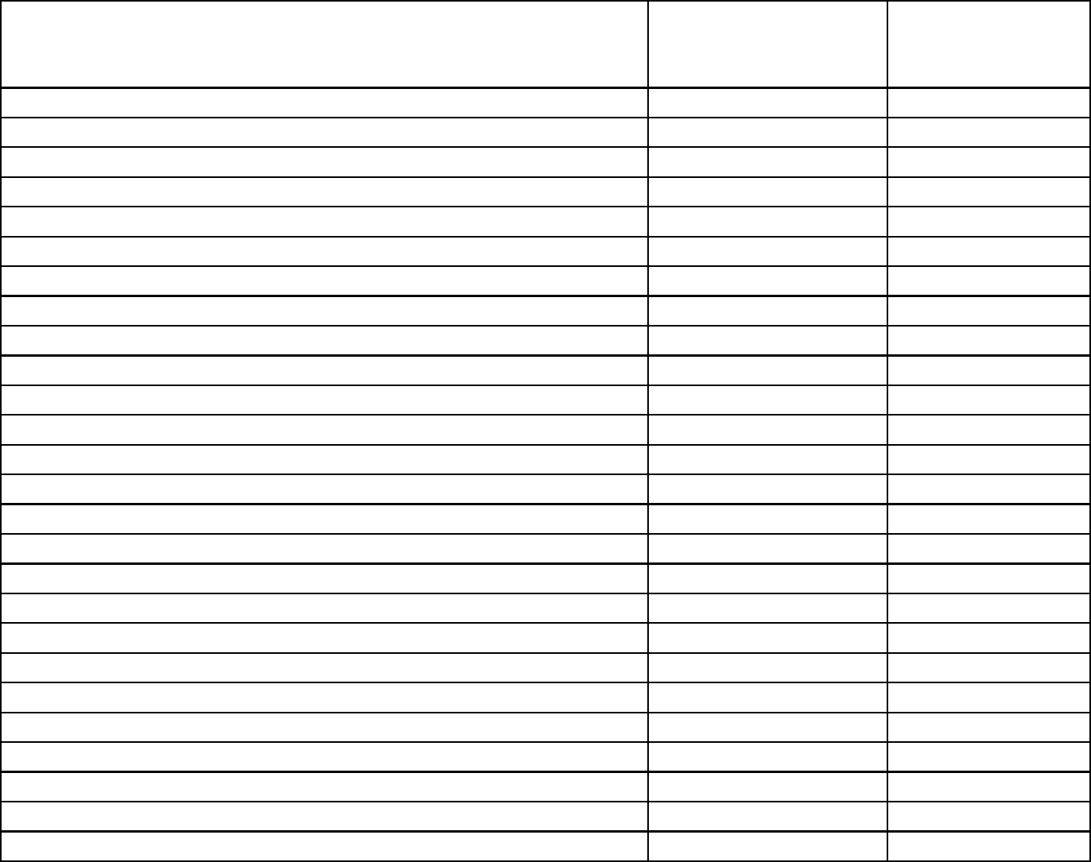

 |  | COSMETIC
Ingredients | CAS No. | ALLERGENS
 |  | INCLUSION (%)
Alpha-Amyl Cinnamic Alcohol | 101-85-9 | 0.0
Alpha-Amyl Cinnamic Aldehyde | 122-40-7 | 0.0
Anisyl Alcohol | 105-13-5 | 0.0
Benzyl Alcohol | 100-51-6 | 0.0
Benzyl Benzoate | 120-51-4 | 0.0
Benzyl Cinnamate | 103-41-3 | 0.0
Benzyl Salicylate | 118-58-1 | 0.0
Cinnamic Alcohol | 104-54-2 | 0.0
Cinnamic Aldehyde (Cinnamal) | 104-55-2 | 0.0
Citral | 5392-40-5 | 0.0
Citronellol | 106-22-9 | 0.0
Coumarin | 91-64-5 | 0.0
Eugenol | 97-53-0 | 0.0
Farnesol | 4602-84-0 | 0.0
Gamma-Methyl lonone (Alpha isomethyl ionone) | 127-51-5 | 0.0
Geraniol | 106-24-1 | 0.0
Hexyl Cinnamic Aldehyde | 101-86-0 | 0.0
HMPCC (Lyral) (Hydroxyisohexyl 3-cyclohexene Carboxaldehye) | 31906-04-4 | 0.0
Hydroxycitronellal | 107-75-5 | 0.0
Isoeugenol | 97-54-1 | 0.0
Lilial (Butylphenyl Methylpropional) | 80-54-6 | 0.0
d-Limonene | 5989-27-5 | 0.2
Linalool | 78-70-6 | 0.0
Methyl Heptine Carbonate (Methyl 2- Octynoate) | 111-12-6 | 0.0
Oak Moss Extracts (Evernia Prunastri) | 90028-68-5 | 0.0
Tree Moss Extracts (Evernia Furfuracea) | 90028-67-4 | 0.0

