DECLARATION FOR THE OBLIGATION TO LABEL ALLERGENIC SUBSTANCES ACCORDING TO REGULATION (EC) NO. 648/2004 ON DETERGENTS

Product Description: | Vánoční sen
INCI-Name (engl.) |  | CAS-No. | Conc. %*
ALPHA-TERPINENE (1) |  | 99-86-5 | < 0.01
ANETHOLE (1) |  | 104-46-1 | 0.499
 |  | 4180-23-8
BENZALDEHYDE (1) |  | 100-52-7 | < 0.01
BENZYL BENZOATE |  | 120-51-4 | 0.025
BETA-CARYOPHYLLENE (1) |  | 87-44-5 | 0.010
CARVONE (1) |  | 99-49-0 | < 0.01
 |  | 6485-40-1
 |  | 2244-16-8
CINNAMAL |  | 104-55-2 | 6.793
CINNAMYL ALCOHOL |  | 104-54-1 | 0.026
CITRAL |  | 5392-40-5 | 0.042
CITRONELLOL |  | 106-22-9 | < 0.01
CITRUS AURANTIUM PEEL OIL (1) |  | 68916-04-1 | 30.000
 |  | 72968-50-4
 |  | 97766-30-8
 |  | 8028-48-6
 |  | 8008-57-9
COUMARIN |  | 91-64-5 | 3.488
EUGENOL |  | 97-53-0 | 14.765
EUGENYL ACETATE (1) |  | 93-28-7 | 0.037
GERANIOL |  | 106-24-1 | < 0.01
GERANYL ACETATE (1) |  | 105-87-3 | < 0.01
HEXAMETHYLINDANOPYRAN (1) |  | 1222-05-5 | 1.003
LIMONENE |  | 5989-27-5 | 28.432
 |  | 5989-54-8
LINALOOL |  | 78-70-6 | 0.191
LINALYL ACETATE (1) |  | 115-95-7 | 0.068
PINENE (1) |  | 80-56-8 | 0.159
 |  | 127-91-3
 |  | 7785-70-8
 |  | 18172-67-3

Page 1/2

INCI-Name (engl.) | CAS-No. | Conc. %*
TERPINEOL (1) | 8000-41-7 | 0.017
 | 98-55-5
 | 138-87-4
 | 586-81-2
TERPINOLENE (1) | 586-62-9 | 0.010
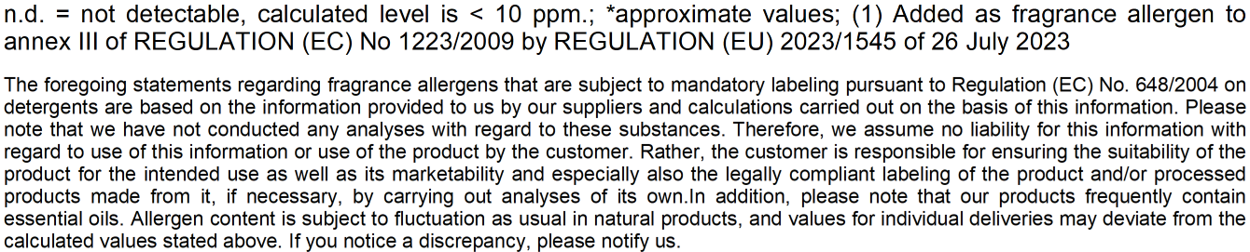

Page 2/2

