DECLARATION FOR THE OBLIGATION TO LABEL ALLERGENIC SUBSTANCES ACCORDING TO REGULATION (EC) NO. 648/2004 ON DETERGENTS

Product Description: | Zázvor pomeranč
INCI-Name (engl.) |  | CAS-No. | Conc. %*
ALPHA-TERPINENE (1) |  | 99-86-5 | 0.073
AMYL CINNAMAL |  | 122-40-7 | < 0.01
BENZALDEHYDE (1) |  | 100-52-7 | 0.020
BENZYL BENZOATE |  | 120-51-4 | 0.458
BETA-CARYOPHYLLENE (1) |  | 87-44-5 | 0.587
BUTYLPHENYL METHYLPROPIONAL |  | 80-54-6 | 0.023
CARVONE (1) |  | 99-49-0 | < 0.01
 |  | 6485-40-1
 |  | 2244-16-8
CINNAMAL |  | 104-55-2 | 7.380
CINNAMOMUM CASSIA LEAF OIL (1) |  | 8007-80-5 | 0.315
 |  | 84961-46-6
CINNAMYL ALCOHOL |  | 104-54-1 | 2.238
CITRAL |  | 5392-40-5 | 0.044
CITRONELLOL |  | 106-22-9 | 0.037
CITRUS AURANTIUM PEEL OIL (1) |  | 68916-04-1 | 9.279
 |  | 72968-50-4
 |  | 97766-30-8
 |  | 8028-48-6
 |  | 8008-57-9
CITRUS LIMON PEEL OIL (1) |  | 84929-31-7 | < 0.01
 |  | 8008-56-8
COUMARIN |  | 91-64-5 | 0.046
EUCALYPTUS GLOBULUS OIL (1) |  | 97926-40-4 | 0.270
 |  | 8000-48-4
 |  | 84625-32-1
EUGENOL |  | 97-53-0 | 7.250
EUGENYL ACETATE (1) |  | 93-28-7 | 0.154
GERANIOL |  | 106-24-1 | 0.033
GERANYL ACETATE (1) |  | 105-87-3 | < 0.01
HEXYL CINNAMAL |  | 101-86-0 | 0.031
ISOEUGENOL |  | 97-54-1 | 0.021
LIMONENE |  | 5989-27-5 | 12.728
 |  | 5989-54-8

Page 1/2

INCI-Name (engl.) | CAS-No. | Conc. %*
LINALOOL | 78-70-6 | 0.720
LINALYL ACETATE (1) | 115-95-7 | 0.035
PINENE (1) | 80-56-8 | 0.233
 | 127-91-3
 | 7785-70-8
 | 18172-67-3
ROSE KETONES (1) | 43052-87-5 | < 0.01
 | 23726-94-5
 | 24720-09-0
 | 23696-85-7
 | 57378-68-4
 | 71048-82-3
 | 23726-92-3
TERPINEOL (1) | 8000-41-7 | 0.120
 | 98-55-5
 | 138-87-4
 | 586-81-2
TERPINOLENE (1) | 586-62-9 | < 0.01
VANILLIN (1) | 121-33-5 | 1.933
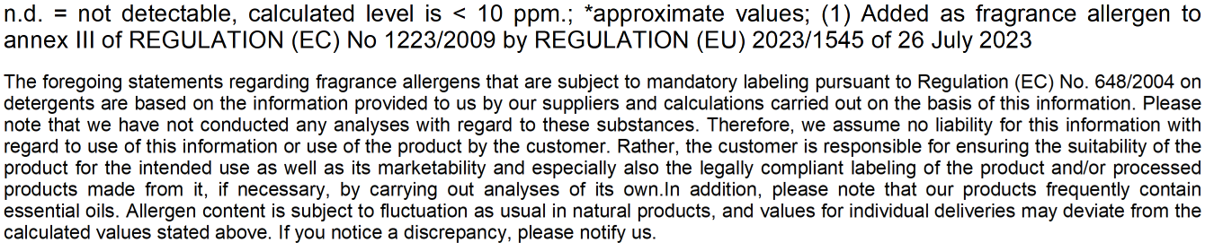

Page 2/2

