TECHNICAL PRODUCT SPECIFICATION

Product Description: Advent

Physical Data

Appearance (according to FL M-AP-001):

Sensoric profile (according to FL M-SP-002):

liquid, clear, yellow

When used properly typical sensoric profile with

following characteristic:
spicy, aromatic, radiant

Flashpoint (according to FL ASTM D6450): | >100 °C
Relative density (according to FL EuAB 2.2.5): | 1.065 | ... 1.085 (d20/4)
Refractive index (according to FL EuAB 2.2.6): | 1.534 | ... 1.554 (nD20)
Optical rotation (according to FL EuAB 2.2.7): | -4° ... +6° (a20)
VOC
EU according to 2004/42/EG: | 13.79 %
CH according to 814.018: | 0.00 %

Other

Vegan: Yes (containing no animal products, including honey)

Recommended Application
Primary application | Secondary application | Recommended dosage
Household cleaner | Alcoholic cleaners | 0.1-0.5%
Household cleaner | Glass cleaner | 0.1-0.5%
Car | Car window-cleaner | 0.05-0.4%

Storage and Handling
Storage: | In tightly closed, preferably full containers in cool,
 | dark and dry storage area. Protect from light.
Storage temperature: | Recommended storage temperature 10-25 °C.
Minimum shelf life: | In suitable, originally closed containers minimum 36
 | months. If used after minimum shelf life, the material
 | has to be analyzed properly.
 | Page 1/2

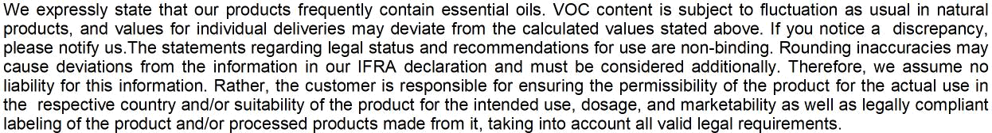

Page 2/2

