TECHNICAL PRODUCT SPECIFICATION

Product Description: Betlémská hvězda

Physical Data

Appearance (according to FL M-AP-001):

Sensoric profile (according to FL M-SP-002):

liquid, yellow to orange

When used properly typical sensoric profile with

following characteristic:
orange, spicy, sweet

Flashpoint (according to FL ASTM D6450):

Relative density (according to FL EuAB 2.2.5):

Refractive index (according to FL EuAB 2.2.6):

Optical rotation (according to FL EuAB 2.2.7):

VOC

EU according to 2004/42/EG:

CH according to 814.018:

Other

Vegan:

(containing no animal products, including honey)

Storage and Handling

Storage:

Storage temperature:

Minimum shelf life:

57 °C

0.937 ... 0.957 (d20/4)

1.508 ... 1.528 (nD20)

+48° ... +58° (a20)

54.01 %

48.02 %

Yes

In tightly closed, preferably full containers in cool, dark and dry storage area. Protect from light.

Recommended storage temperature 10-25 °C.

In suitable, originally closed containers minimum 36 months. If used after minimum shelf life, the material has to be analyzed properly.
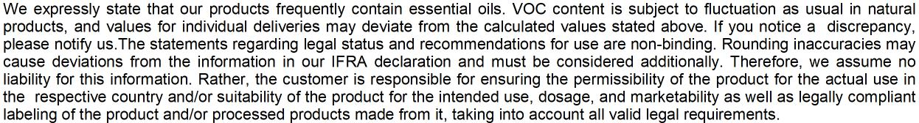

Page 1/1

