TECHNICAL PRODUCT SPECIFICATION

Product Description: Tichá noc

Physical Data

Appearance (according to FL M-AP-001):

Sensoric profile (according to FL M-SP-002):

liquid, clear, yellowish to brownish

When used properly typical sensoric profile with

following characteristic:
spicy

Flashpoint (according to FL ASTM D6450): |  | 59 °C
Relative density (according to FL EuAB 2.2.5): |  | 0.950 ... 0.970 (d20/4)
Refractive index (according to FL EuAB 2.2.6): |  | 1.507 ... 1.527 (nD20)
Optical rotation (according to FL EuAB 2.2.7): |  | +44° ... +54° (a20)
VOC
EU according to 2004/42/EG: |  | 52.01 %
CH according to 814.018: |  | 42.63 %
Other
Vegan: |  | Yes
(containing no animal products, including honey)
Recommended Application
Primary application | Secondary application |  | Recommended dosage
Airfreshner | Fragrance oil |  | 2%
Candles & Wax | Paraffin |  | 2.0-5.0%
Storage and Handling
Storage: |  | In tightly closed, preferably full containers in cool,
 |  | dark and dry storage area. Protect from light.
Storage temperature: |  | Recommended storage temperature 10-25 °C.
Minimum shelf life: |  | In suitable, originally closed containers minimum 36
 |  | months. If used after minimum shelf life, the material
 |  | has to be analyzed properly.
 |  | Page 1/2

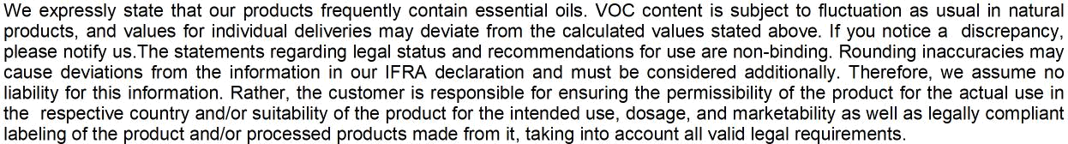

Page 2/2

