TECHNICAL PRODUCT SPECIFICATION

Product Description: Vánoční sen

Physical Data

Appearance (according to FL M-AP-001):

Sensoric profile (according to FL M-SP-002):

liquid, clear, yellow to orange

When used properly typical sensoric profile with

following characteristic:
orange, aromatic, floral, spicy

Flashpoint (according to FL ASTM D6450): |  | 61 °C
Relative density (according to FL EuAB 2.2.5): |  | 0.998 ... 1.018 (d20/4)
Refractive index (according to FL EuAB 2.2.6): |  | 1.502 ... 1.522 (nD20)
Optical rotation (according to FL EuAB 2.2.7): |  | +30° ... +40° (a20)
VOC
EU according to 2004/42/EG: |  | 33.16 %
CH according to 814.018: |  | 28.43 %
Other
Vegan: |  | Yes
(containing no animal products, including honey)
Recommended Application
Primary application | Secondary application |  | Recommended dosage
Household cleaner | Universal cleaner, neutral |  | 0.1-1.0%
Household cleaner | Alcoholic cleaners |  | 0.1-0.5%
Household cleaner | Dishwashing liquid, pearl |  | 0.1-0.5%
 | effect
Soaps | Toilet soap |  | 0.8-1.5%
Soaps | Hand washing paste |  | 0.1-0.3%
Soaps | Liquid soap, clear |  | 0.2-0.5%
Soaps | Liquid soap, pearl effect |  | 0.2-0.5%
Shampoos | Shampoo, clear |  | 0.2-0.5%
Shampoos | Shampoo, perl effect |  | 0.2-0.5%
Shower, Bath & Sauna | Shower Bath, Shower Gel & |  | 0.5-1.5%
 | Foam Bath

Page 1/2

Shower, Bath & Sauna | Bath salts | 0.5-1.8%
Shower, Bath & Sauna | Sauna oils | 1.0-3.0%
Airfreshner | Pumpspray | 0.2-1.0%
Airfreshner | Fragrance oil | 3%
Airfreshner | Potpourri | 3%

Storage and Handling

Storage: In tightly closed, preferably full containers in cool,

dark and dry storage area. Protect from light.

Storage temperature: Recommended storage temperature 10-25 °C.

Minimum shelf life: In suitable, originally closed containers minimum 36

months. If used after minimum shelf life, the material has to be analyzed properly.
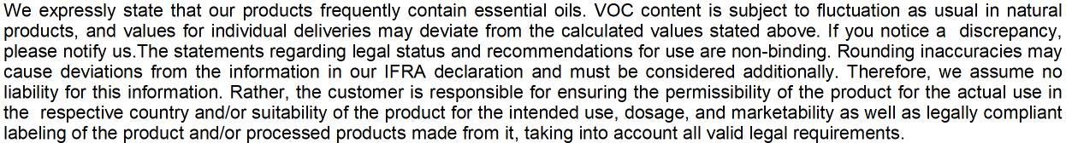

Page 2/2

