TECHNICAL PRODUCT SPECIFICATION

Product Description: Zázvor pomeranč

Physical Data

Appearance (according to FL M-AP-001):

Sensoric profile (according to FL M-SP-002):

liquid, clear, yellowish to brownish

When used properly typical sensoric profile with

following characteristic:
woody, spicy, typical

Flashpoint (according to FL ASTM D6450): | 75 °C
Relative density (according to FL EuAB 2.2.5): | 0.940 | ... 0.960 | (d20/4)
Refractive index (according to FL EuAB 2.2.6): | 1.473 | ... 1.493 | (nD20)
Optical rotation (according to FL EuAB 2.2.7): | +9° ... +19° (a20)
VOC
EU according to 2004/42/EG: | 75.40 %
CH according to 814.018: | 12.85 %

Legal Information

Other

Vegan: Yes (containing no animal products, including honey)

Recommended Application

Primary application Secondary application Recommended dosage

Candles & Wax Paraffin 2.0-5.0%

Page 1/2

Storage and Handling

Storage: In tightly closed, preferably full containers in cool,

dark and dry storage area. Protect from light.

Storage temperature: Recommended storage temperature 5-15 °C.

Minimum shelf life: In suitable, originally closed containers minimum 36

months. If used after minimum shelf life, the material has to be analyzed properly.
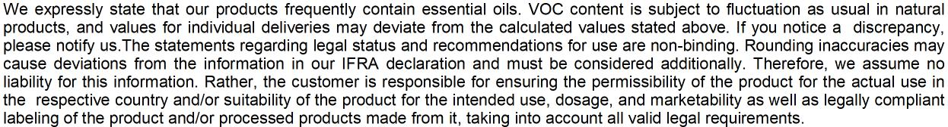

Page 2/2

